MINI PROJECT REPORT

**On**

**CLOUD BASED BUSS PASS SYSTEM**

**SUBMITTED BY-**

**AAYUSHI RAI (171510003)**

**PRANJUL SINGHAL (171510040)**

**SAKSHAM JOHRI (171510046)**

Department of Computer Engineering & Applications

**Institute of Engineering & Technology**



**GLA UNIVERSITY**

**MATHURA-281406, INDIA**

**2019**

**SYNOPSIS**

**Student Information:**

|  |  |
| --- | --- |
| Name: Aayushi Rai  Pranjul Singhal  Saksham Johri | University Roll. No.: 171510003  171510040  171510046 |
| Mobile: +91 7454915447  +91 9756542969  +91 8979808914 | Email: [ayushi.rai_ccv17@gla.ac.in](mailto:ayushi.rai_ccv17@gla.ac.in)  [pranjul.singhal_ccv17@gla.ac.in](mailto:pranjul.singhal_ccv17@gla.ac.in)  saksham.johri_ccv17@gla.ac.in |

**Project Information:**

|  |  |
| --- | --- |
| Title Of Project | Cloud Based Bus Pass System |
| Role & Responsibility | Create a personal cloud, Storage of huge data, have a backup,  Reliable for passengers |
| Technical Details | Hardware required: Personal computer with minimum 4GB  RAM, Hard Disk 50GB,  Processor Intel CORE i3  Software required: OS – Windows 10, IDE – AWS  Front end – html, CSS, php  Back end – Cloud Shell |
| Project Implementation Details | Fully Implemented |
| Project Duration | V Semester |
| Supervised by | Mr. Vivek Sharma |

**Summary of the Project Work:**

|  |
| --- |
| Customer can buy the bus ticket over the Internet, 24 hours a day, this solves the issue of ticket being misplaced or stolen. Users can recharge through cc or debit car.  The site may get overloaded due to huge number of users visiting at once. Thus this system is built up using cloud infrastructure for improved performance.  • Using this website we can check all details related Bus pass and instruction like how to renew pass how to update it, and also provide details of student discount.  • This website keeps all information of all Bus passes.  • Passengers first need to verify themselves the system using various through registration. Once verified the system allows them to book passes for any route online.  • Users can recharge through cc debit cards. |

**ACKNOWLEDGEMENT**

The success and final outcome of this project required a lot of guidance and assistance from many people and we are extremely privileged to have got this all along the completion of my project. All that we have done is only due to such supervision and assistance and we would not forget to thank them.

We respect and thank **Mr. Vivek Sharma** for providing me an opportunity to do the project work and giving us all support and guidance which made us complete the project duly. We are extremely thankful to him for providing such a nice support and guidance, although he had busy schedule managing the corporate affairs. We owe our deep gratitude to our project guide **Mr. Vivek Sharma** who took keen interest on my project work and guided us all along, till the completion of our project work by providing all the necessary information for developing a good project. After doing this project we can confidently say that this experience has not only enriched me with technical knowledge but also has unparsed the maturity of thought and vision. The attributes required in being a successful professional .

Aayushi Rai(171510003)

Pranjul Singhal(171510040)

Saksham Johri(171510046)

**Department of computer Engineering and Applications**

**GLA University, Mathura**

**17 km. Stone NH#2, Mathura-Delhi Road, P.O. – Chaumuha,**

**Mathura – 281406**



**Declaration**

I hereby declare that the work which is being presented in the Mini Project “**Cloud Based Buss Pass System”,** in partial fulfilment of the requirements for Mini Project viva voice, is an authentic record of our own work carried under the supervision of **Mr. Vivek Sharma.**

Signature of Candidates:

Name of Candidates: Aayushi Rai (171510003)

Pranjul Singhal (171510040)

Saksham Johri (171510046)

Course: B.Tech (CCV)

Year: III

Semester: V

**ABSTRACT**

Using Cloud we have Built a Bus pass system through which Customer can buy the bus ticket over the Internet, 24 hours a day, this solves the issue of ticket being misplaced or stolen. Users can recharge through cc or debit car.

The site may get overloaded due to huge number of users visiting at once. Thus this system is built up using cloud infrastructure for improved performance.

• Using this website we can check all details related Bus pass and instruction like how to renew pass how to update it, and also provide details of student discount.

• This website keeps all information of all Bus passes.

• Passengers first need to verify themselves the system using various through registration. Once verified the system allows them to book passes for any route online.

• Users can recharge through cc or debit cards.

Contents

1. Introduction ……………………………………………………………………….. 1
2. Technology Review…………………………………………………………….. 2
   1. HTML…………………………………………………………………2
   2. CSS……………………………………………………………………2
   3. PHP……………………………………………………………………2
   4. JAVA Script…………………………………………………………...2
   5. Amazon Web Services…………………………………………………………2
3. Technology.……………………………………………………………….... 3
   1. Software Requirements…………………………………………………3
   2. Hardware Requirements…………………………………………………3
4. Data Modelling Diagram………………………………………………….... 3
   1. Context Level DFD…………………………………………………3
   2. Use Case Diagram………………………………………3
   3. Sequence Diagram………………………………………3
   4. Activity Diagram………………………………..3
   5. E-R Diagram………………………………………………3
5. Data Dictionary ….………………………………………………....18
6. Glimpse Of Project ……………………………………………………......20
7. Conclusion ………………………………………………………………...21
8. Bibliography…………………………………………………………………….30

**CHAPTER-1**

**INTRODUCTION**

This project is created to provide “safe, reliable, saving, efficient and affordable” services for user. This idea would help the user in a better way. As per the previous system the user had to do each and every process manually, but this system helps user to make the work bit faster. The user can then take print out of this bus pass from their mail id and use them.

The bus pass will be differ for different types of users. In this bus pass, all the required details such as person name, address, date of birth, mail id, validity period, amount paid and photo copy of the person are provided. Working organization details will be provided in employees bus pass. The renewal process can be done either monthly or yearly as per user wish. Based on that renewal period amount will be deducted.

• Using this website we can check all details related Bus pass and instruction like how to renew pass how to update it, and also provide details of student discount.

• This website keeps all information of all Bus passes.

• Passengers first need to verify themselves the system using various through registration. Once verified the system allows them to book passes for any route online.

• Users can recharge through cc or debit cards.

**CHAPTER-2**

**TECHNOLOGY REVIEW**

**2.1 HTML**

**HTML** stands for **Hyper Text Markup Language**, which is the most widely used language on Web to develop web pages. **HTML** was created by Berners-Lee in late 1991.

**HTML** is a MUST for students and working professionals to become a great Software Engineer specially when they are working in Web Development Domain. I will list down some of the key advantages of learning HTML:

* You can create a website or customize an existing web template if you know HTML well.
* If you want to start a career as a professional web designer, HTML and CSS designing is a must skill.
* If you want to optimize your website, to boost its speed and performance, it is good to know HTML to yield best results.
* Once you understands the basic of HTML then other related technologies like javascript, php, or angular are become easier to understand.

**2.2 CSS**

**Cascading Style Sheets** (**CSS**) is a stylesheet language. CSS is one of the core languages of the **open web** and is standardized across Web browsers. CSS is used to style and lay out web pages — for example, to alter the font, colour, size, and spacing of your content, split it into multiple columns, or add animations and other decorative features. The name cascading comes from the specified priority scheme to determine which style rule applies if more than one rule matches a particular element. This cascading priority scheme is predictable.

**2.3 PHP**

The PHP Hypertext Preprocessor (PHP) is a programming language that allows web developers to create dynamic content that interacts with databases. PHP is basically used for developing web based software applications.

PHP is a must for students and working professionals to become a great Software Engineer specially when they are working in Web Development Domain. PHP is a server side scripting language that is embedded in HTML. It is used to manage dynamic content, databases, session tracking, even build entire e-commerce sites.

It is integrated with a number of popular databases, including MySQL, PostgreSQL, Oracle, Sybase, Informix, and Microsoft SQL Server.

**2.4 JAVASCRIPT**

JavaScript is a programming language that adds interactivity to your website (for example games, responses when buttons are pressed or data is entered in forms, dynamic styling, and animation). JavaScript itself is fairly compact yet very flexible. Developers have written a large variety of tools on top of the core JavaScript language, unlocking a vast amount of extra functionality with minimum effort. These include:

* Browser Application Programming Interfaces (APIs) — APIs built into web browsers, providing functionality like dynamically creating HTML and setting CSS styles, collecting and manipulating a video stream from the user's webcam, or generating 3D graphics and audio samples.
* Third-party APIs — Allow developers to incorporate functionality in their sites from other content providers, such as Twitter or Facebook.
* Third-party frameworks and libraries — You can apply these to your HTML to allow you to rapidly build up sites and applications.

**2.5 AMAZON WEB SERVICES**

**Amazon Web Services** (**AWS**) is a subsidiary of Amazon that provides on-demand cloud computing platforms and APIs to individuals, companies, and governments, on a metered pay-as-you-go basis. In aggregate, these cloud computing web services provide a set of primitive abstract technical infrastructure and distributed computing building blocks and tools. One of these services is Amazon Elastic Compute Cloud, which allows users to have at their disposal a virtual cluster of computers, available all the time, through the Internet.

**CHAPTER-3**

**TECHNOLOGY**

**3.1 Software Requirements:**

3.1.a Front End: HTML, CSS, PHP, Javascript

3.1.b Back End: Cloud Shell

3.1.c Operating System: Windows 10

**3.2 Hardware Requirements:**

3.2.a Processor: intel CORE i5

3.2.b Hard Disk: 64 bits

3.2.c RAM: 8 GB

## CHAPTER-4

## DATA MODELLING DIAGRAM

## List of Symbols/Notation

## Notations for Dataflow Diagram:

ONLINE BUS PASS SYSTEM
v
LIST OF SYMBOLS/NOTATION
Notations for Dataflow Diagram:
Graphical Notation Name
Process
Flow of ...

**Notations for Use Case Diagram:**

ONLINE BUS PASS SYSTEM
v
LIST OF SYMBOLS/NOTATION
Notations for Dataflow Diagram:
Graphical Notation Name
Process
Flow of ...

#### Notations for Sequence Diagram:

ONLINE BUS PASS SYSTEM
vi
Notations for Sequence Diagram:
Graphical Notation Name
Message Return
Message
Object Lifeline
N...

**Notations for Activity Diagram:**

ONLINE BUS PASS SYSTEM
vi
Notations for Sequence Diagram:
Graphical Notation Name
Message Return
Message
Object Lifeline
N...

**Notations for E-R Diagram:**

ONLINE BUS PASS SYSTEM
vii
Diamond
It is used for representing the
conditions such as it-then-else
or repeat until.
Notati...

**4.1 Data Flow Diagram:**

ONLINE BUS PASS SYSTEM
11
4.1 DATA FLOW DIAGRAM
4.1.1 Context Level DFD
 

**4.2 Use Case Diagram:**

ONLINE BUS PASS SYSTEM
15
4.2 USE CASE DIAGRAM
4.2.1 Use case Diagram for User
 

**4.3 Sequence Diagram:**

ONLINE BUS PASS SYSTEM
16
4.3 SEQUENCE DIAGRAM
 

**Chapter-6**

**INTRODUCTION TO TKINTER WITH PYTHON**

**6.1 Designing User Interfaces**

User interfaces are what allows end users to interact with an application. An application can be excellent, but without a good user interface, it becomes more difficult to use, and less enjoyable. It is thus very important to design good user interfaces. Designing user interface takes place at two different levels: the graphical level and the event level. Graphical elements of a user interface are called widgets. Widgets are basic components like buttons, scrollbars, etc. But user interfaces involve more than a collection of widgets placed in a window. The application must be able to respond to mouse clicks, keyboard actions or system events such as minimizing the window. For this to happen, events must be associated to some pieces of code. This process is called binding. The next two chapters will cover each level in more details, but this chapter will present an overview of Tkinter and explain why it has become the leading GUI toolkit for the Python language.

**6.2 What is Tkinter?**

Tkinter is an open source, portable graphical user interface (GUI) library designed for use in Python scripts. Tkinter relies on the Tk library, the GUI library used by Tcl/Tk. Thus, Tkinter is implemented using multiple layers. Several competing GUI toolkits are available to use with the Python language, namely:

**wxPython :** A wrapper extension for wxWindows, a portable GUI library originally developed for the C++ language. It is the second most popular GUI toolkit for Python since it is considered excellent for complex interface design.

**JPython (Jython) :** Since it is implemented in java, JPython has access to Java GUI libraries, namely SWING and AWT. Recently, JTkinter has been implemented and provides a Tkinter port to JPython using the Java Native

**6.3 Why Tkinter?**

With all the competing GUI toolkits available for the Python language, what makes Tkinter stand out of the rest? Why is it the most popular toolkit for use interface design?

To find the answer, one must look at the advantages that it offers.

1. **Layered design** The layered approach used in designing Tkinter gives Tkinter all of the advantages of the TK library. Therefore, at the time of creation, Tkinter inherited from the benefits of a GUI toolkit that had been given time to mature. This makes early versions of Tkinter a lot more stable and reliable than if it had been rewritten from scratch. Moreover, the conversion from Tcl/Tk to Tkinter is really trivial, so that Tk programmers can learn to use Tkinter very easily.

2. **Accessibility Learning** Tkinter is very intuitive, and therefore quick and painless. The Tkinter implementation hides the detailed and complicated calls in simple, intuitive methods. This is a continuation of the Python way of thinking, since the language excels at quickly building prototypes.

**6.4 Fundamentals Of Tkinter**

Consider the following diagram, it shows how an application actually executes in Tkinter:

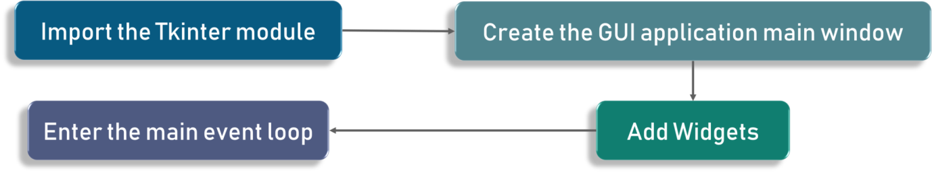

**CHAPTER-7**

**SOURCE CODE**

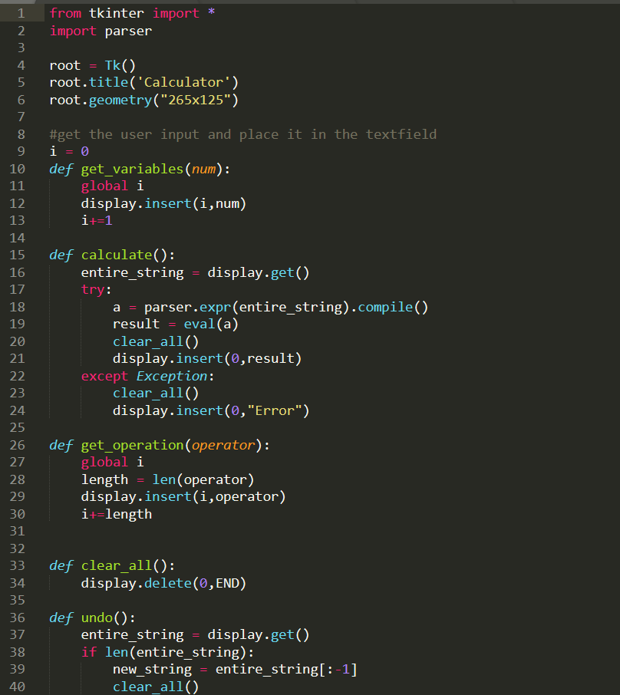

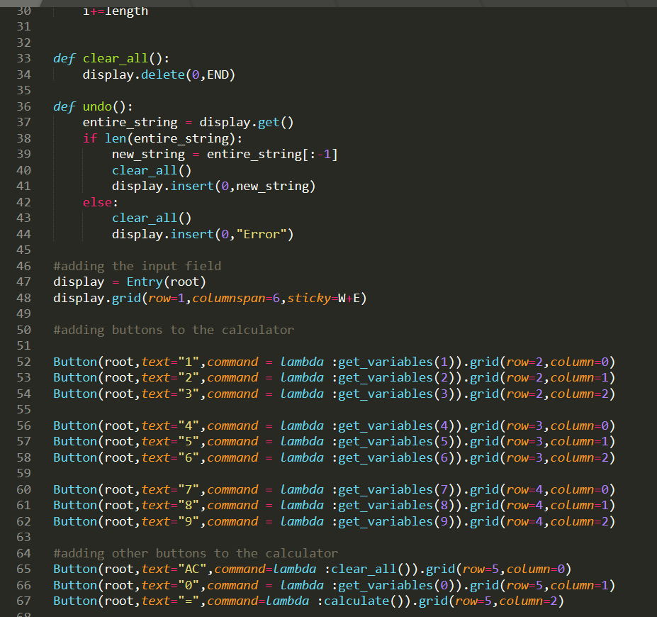

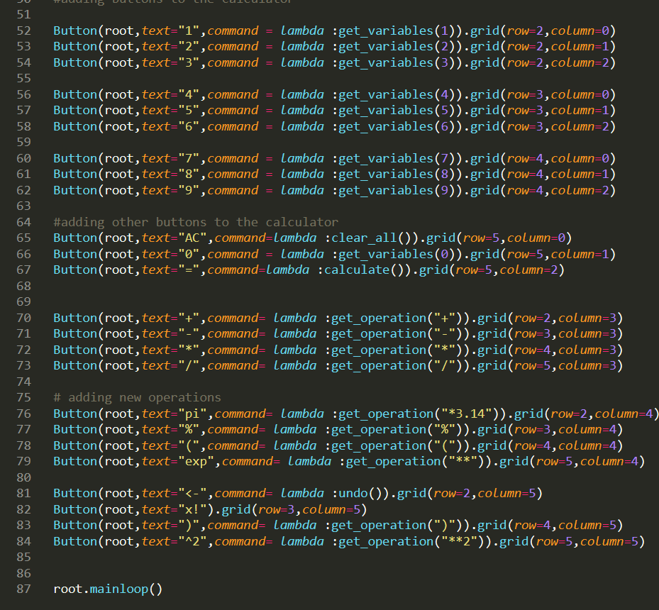

**CHAPTER-8**

**USE CASE DIAGRAM & OUTPUT**

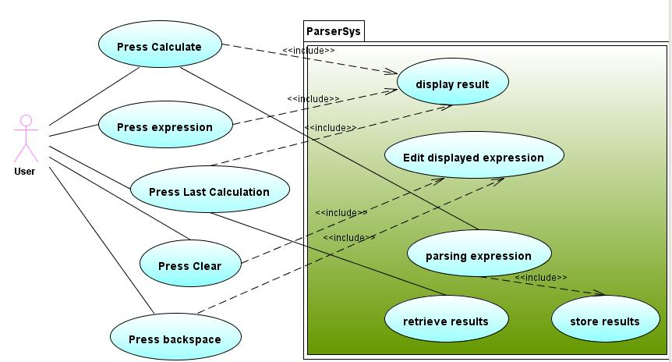

Fig 8.1: Use Case Diagram for Calculator

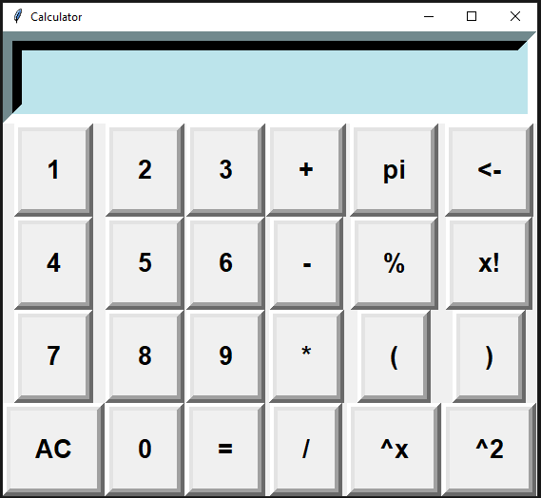

**Fig 8.2: Look of my Calculator**

**CHAPTER-9**

**CONCLUSION**

**9.1 CONCLUSION**

Bus pass Registration and Renewal System Project is a real time project which is useful for the people who are facing problems with the current manual work of bus pass Registration and renewal. It also increases the validity period, frequently Warns to the student before completion of his validity period by website. His / Her Renewal or Registration can be done using a voucher or even by a credit card. This online bus pass registration application will help students save their time and renewal bus passes without standing in a line for hours near counters. Initially people need to register with the application by submitting details of photo, address proof, and required details and submit through online. They will verify your details and if they are satisfied they will approve bus pass. You can even renewal using credit card or other wire transfer methods.

**Chapter-10**

**BIBLIOGRAPHY**

**10.1 BIBLIOGRAPHY**

* [**www.w3schools.com**](http://www.w3schools.com)
* [**https://www.geeksforgeeks.org**](https://www.geeksforgeeks.org/)
* [**https://www.tutorialspoint.com**](https://www.tutorialspoint.com/)
* [**www.quora.com**](http://www.quora.com)